1. Project title

2. Introduction

I. Overview

i. Technical Stack

II. Purpose

3. Result

I. Screenshot of output

II. Code Repository

4. Application

5. Conclusion

6. Future Scope

1. Project title

Application for Plasma Donation using AWS

2. Introduction

Studies say that convalescent plasma therapy can help provide short-term immunity against the COVID-19 virus as well Even though the therapy is extremely effective, plasma donation has a certain limitation as to who can or cannot donate. A potential plasma donor, who has recovered from COVID-19 (and is symptom-free for 14 days) can deposit plasma at a certified bank once specific testing and requirements are met with. Currently, people between the ages of 18-50 are being allowed to donate. Plasma collected from one person is then transfused onto two COVID patients.To build a serverless computation using AWS for plasma donation

I. Overview

We have options for Registering for Plasma donation and Requesting for plasma donors. In Registration, we collect details about plasma donor like name, email, mobile number, city, whether Covid-19 infected or uninfected, blood group. Registration will be complete after they have given their password. Once registration is successful, donor can login to their account. Using Request form, anyone can request for Plasma donation. Donors will be intimated for availability.

i. Technical Stack

* Programming Language: Python 3.8
* Database: Dynamo DB - AWS
* Serverless Computing: Lambda - AWS
* Identify and Access Management: AWS IAM
* API: AWS API Gateway
* Mobile message communication: FAST2SMS
* Python Modules:
* Flask – Web application
* Boto3 – AWS SDK for Python
* Requests – API requests

II. Purpose

To intimate the person through messages

3. Result

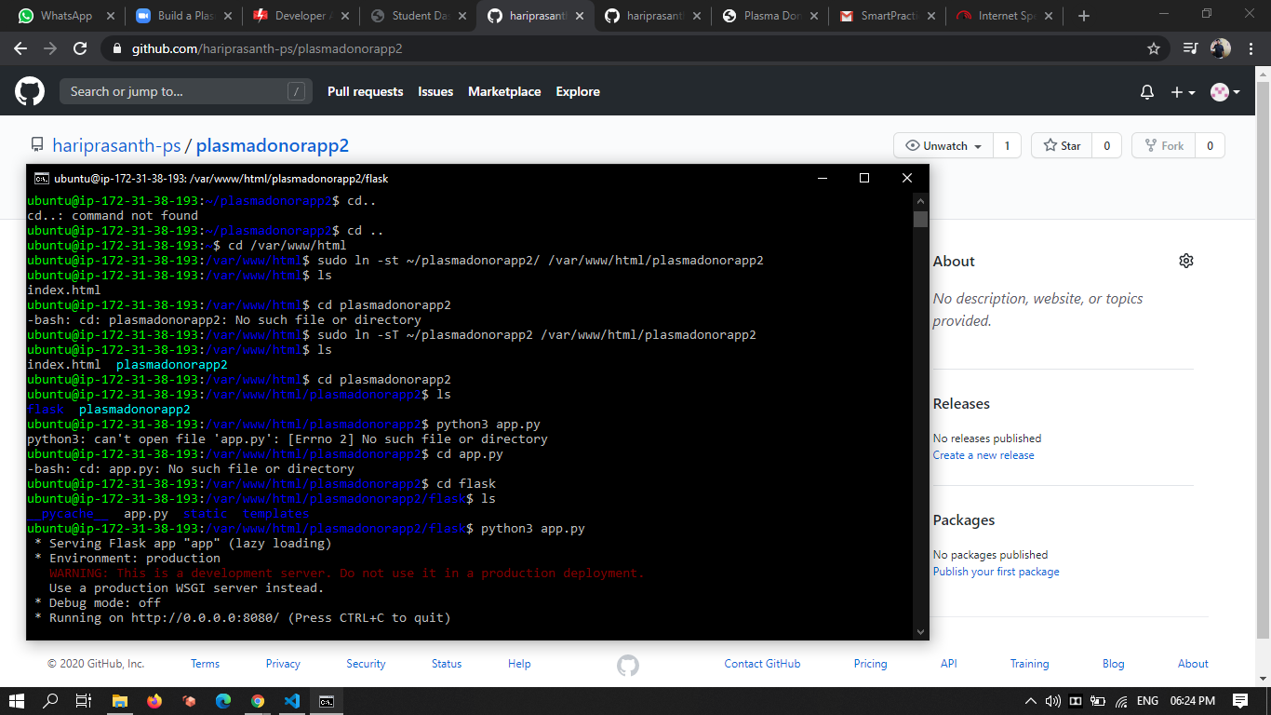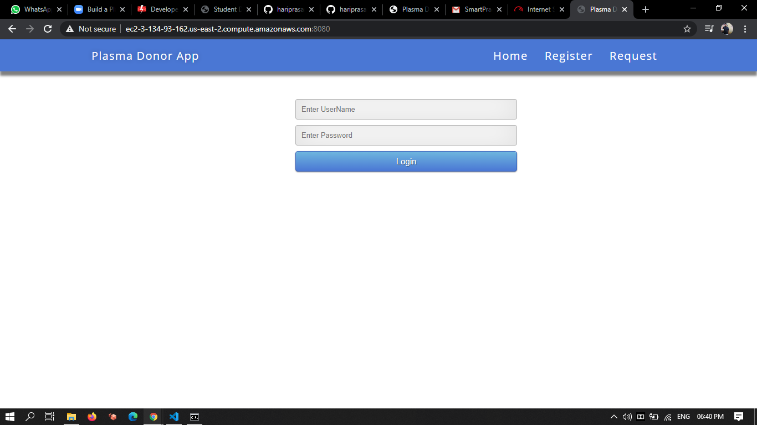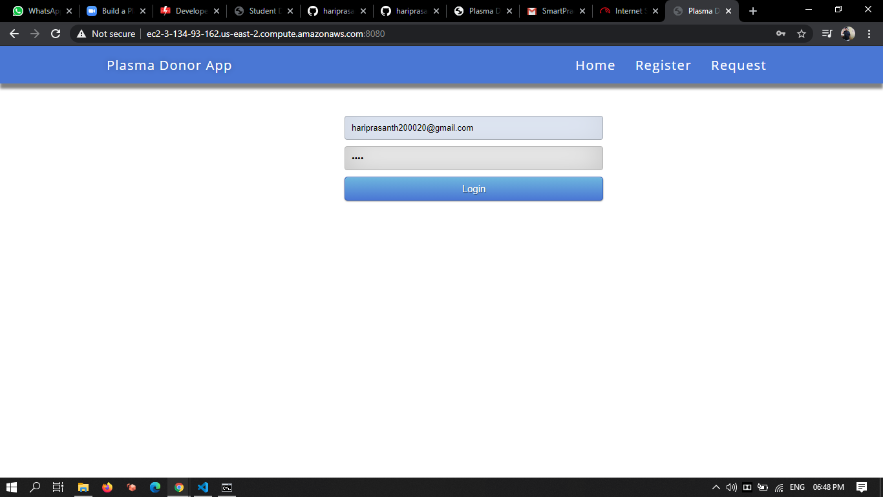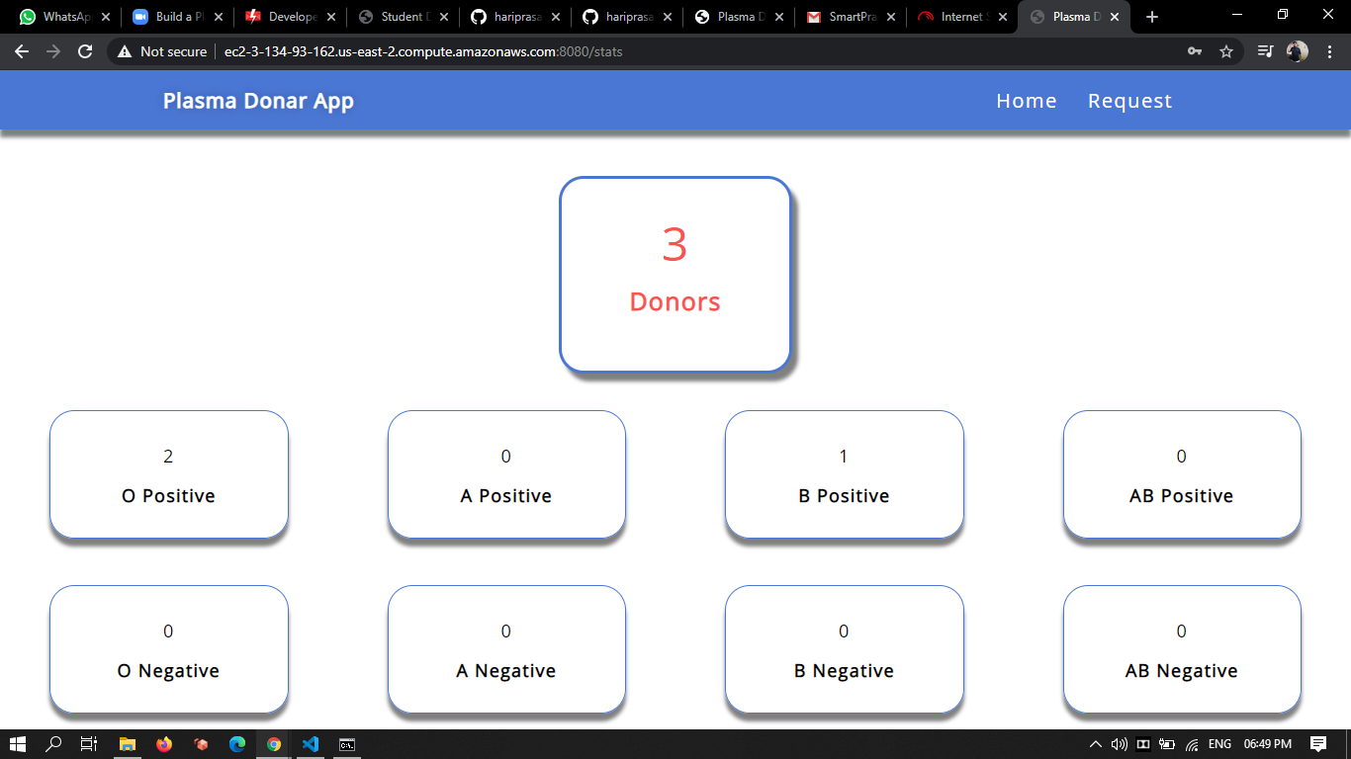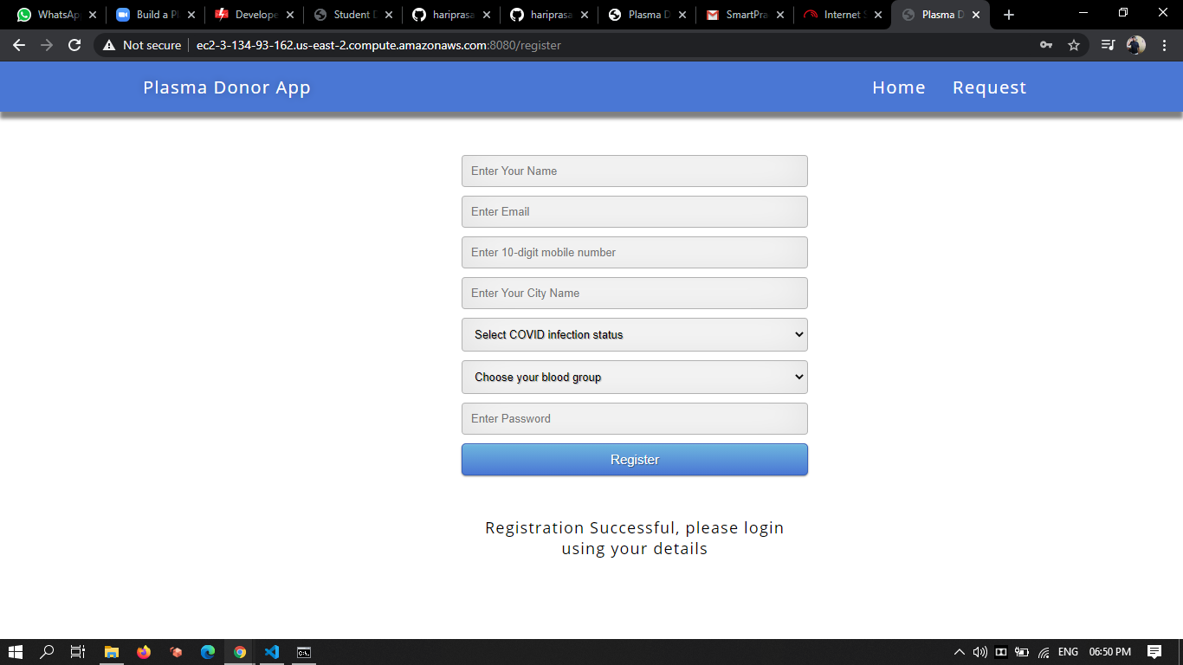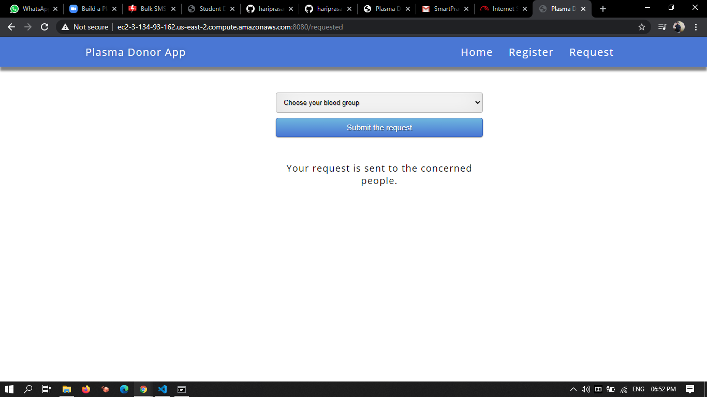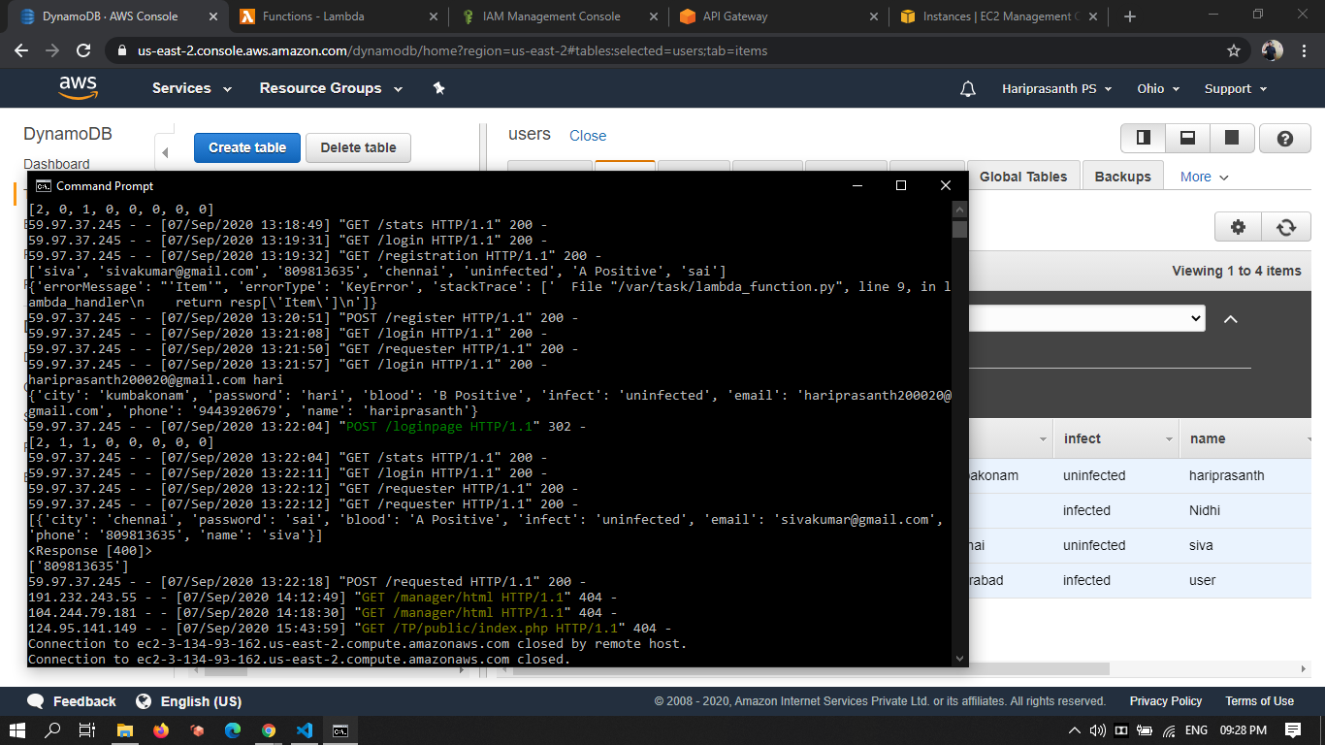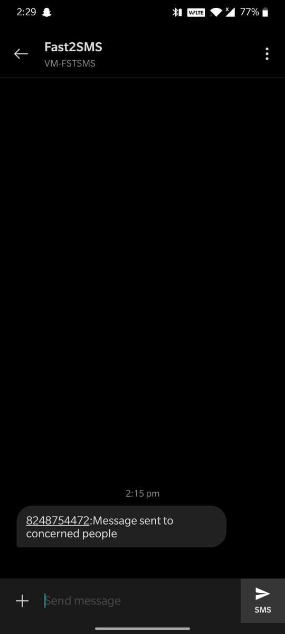

II. Code Repository

https://github.com/hariprasanth-ps/plasmadonorapp2/tree/master/flask

4. Application

This can be used to send the need for Plasma messages directly to the volunteers through phone number which can cure the infected COVID-19 patients regardless of the time.

5. Conclusion

The we created a serverless computation using AWS for Plasma Donor.

6. Future Scope

We can easily access to add, update and delete the data in future since it’s a serverless computing